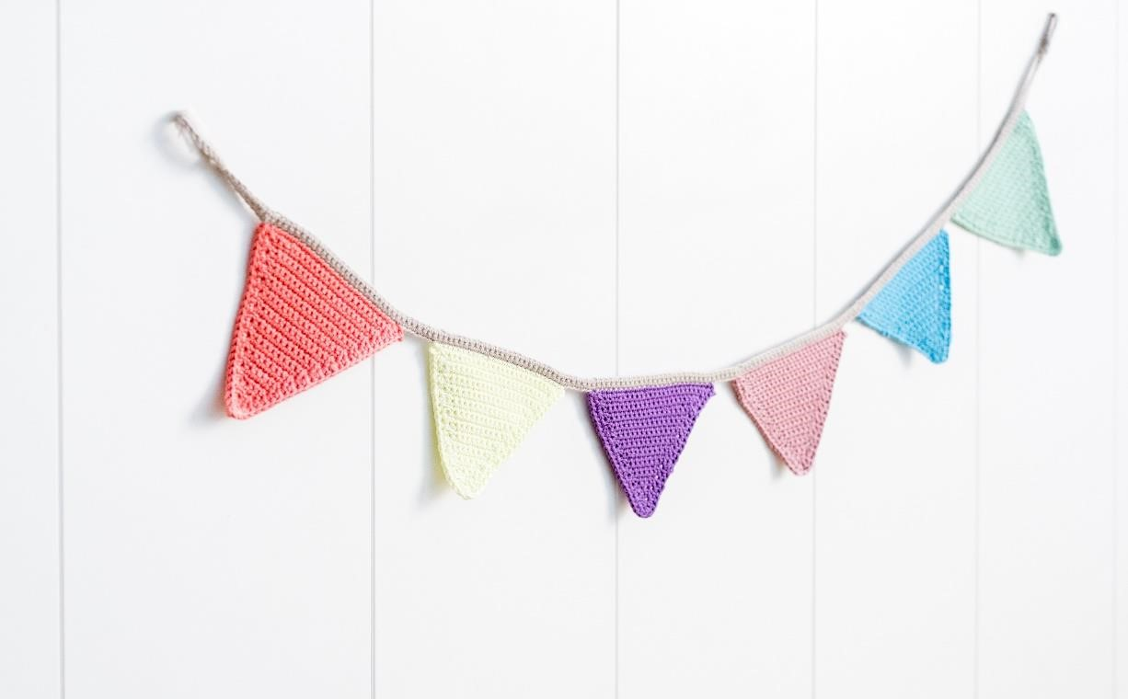
We invite you to participate in our Artisan Event again this year.

Jackson County Fair
Artisan

Event

Art & Handmade Crafts

July 26

and/or 27
,
2024

10
a.m.
-
7
p.m.

The cost is only $25

(
per day) Friday and
/o
r Saturday

INFORMATION:
- Booth location will be in NEW commercial building. Tables, chairs, etc. are your responsibility.
- This event is open to Arts & Crafts.
- Hours are 10:00 am--7:00 pm Friday and Saturday. Set up starting at 8:00 am • No Electricity Available.
- Booth Size will be 8 x 10 If larger area is needed, please contact us
- Please send $25 (per day) with your registration.
Contact for more information: contact@jacksoncountyfairmn.com

Please have registration turned in by Saturday, July 1, 2024.
Mail Registration & $25(per day) to:
Jackson Co Fair
PO Box 175
Jackson, MN 56143

Name:_____________________________________________________________________
Business Name:_____________________________________________________________
Craft Type/Vendor items: Please Be Specific: _____________________________________
__________________________________________________________________________
Address:___________________________________________________________________
Phone:_____________________________________________________________________
Email:_____________________________________________________________________ Attending: Friday __________ Saturday __________ Both Days _________
Signature:_____________________________________Date: ________________________

